Memories of WWII Live On
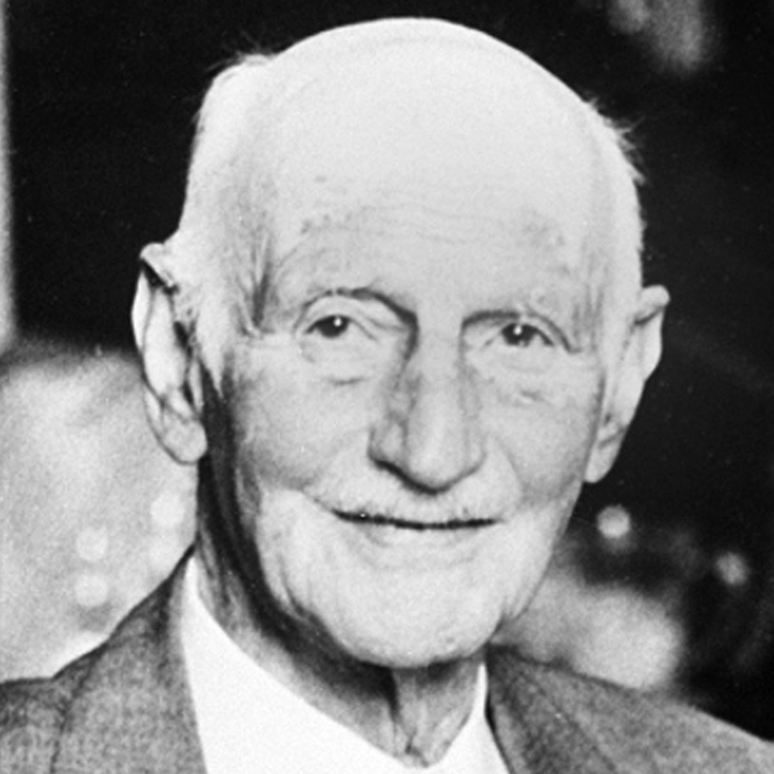
After a long and hard war passed by, Adolf Hitler and the Nazis were finally defeated. I, Otto Frank, was a Jew in hiding at that time, and I was salivating for the war to come to an end. During the war, Jewish people were sent off to “disease-ridden” concentration camps, where they were forced to do all kinds of gruesome things. Jews were hated during 1939, and honestly, I’m not sure why. Adolf Hitler had always made us Jews look bad, and created a bad image of us. He thought Jews were inferior to the other races at that time, and brainwashed people into thinking that Jews weren’t even human. Jews seemed like a renegade to the public. After my oldest daughter, Margot, received a work letter demanding her to report to work camp, my family and I went into hiding. We didn’t want to get caught, and I truly thought that we would survive. It was our only hope at surviving this hardship anyway. We genuinely loathed those places, and risked not only our lives, but our friend’s, partner’s, and acquaintance’s lives were also at the periphery of being caught.

My family and I went to hide in the back of a warehouse, where it had always been unseen. We were later joined by the Van Pels family, and Fritz Pfeffer. It was the place that we would call home for the rest of the war, and I won’t say that it was too bad, nor was it any good either. We called our refuge the “Secret Annex,” and hoped to stay alive there for as long as possible. The environment there was inanimate. Compared to our old home, it was nothing, but compared to other Jews in hiding, it was enough for us to survive. I know that my family despised it at first, and I will admit that I, personally, despised it too at that time, but it took some time to get used to. I remember the ridiculous walls, thin as a sheet of blanket, had always prevented us from speaking, so we all whispered. I remember the agonizing feeling always getting stuck in this one building, never allowed to go out and enjoy the fresh air that everyone was dying for. I saw my daughter Anne once, peeking out the attic window, and I could feel her desperation for that beautiful air. I felt a strong pity on her, but for myself too. Why had our lives turn into this? The living conditions were absolutely horrible, and nobody should face what we had to. I will never forget my moments during WWII.

