Biography
El artista se llama Olga Sinclair. Nacido el 1 de enero de 1957, se crió en la ciudad de Panamá.
Olga Sinclair first began her art career with her father, Alfredo Sinclair, who was an artist himself. She then took off from there. She began her studies in 1976, in a school called “Applied Arts” in Madrid, Spain. 1979 was when she joined Santa Maria la Antigua, University in Panama. In 2007, she developed a new artistic experience from her teacher.
Sinclair is a figurative artist, usually painting people or “figures.” However, she is capable of drawing anything.
She has a world record of having 5,048 kids in Panama paint a mural simultaneously for about 3 minutes.
She is still alive today.
Bibliography
- www.OlgaSinclair.com
- www.biography.com
- http://www.guinnessworldrecords.com/news/2014/2/thousands-of-children-celebrate-100-years-of-panama-canal-with-painting-record-55146/

Tiffany Chen and Ben Craven
700
1/4/15

Olga Sinclair
1957- Present Day
Panama

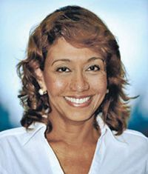

By: Tiffany Chen
And
Ben Craven
Caballo by:Olga Sinclair
Year:2005

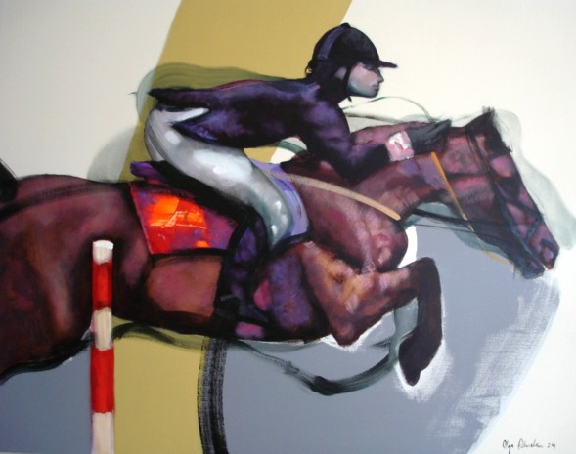
Description of the Picture:
- Hay sombras en el fondo para
- Hay un obstáculo para mostrar el caballo está saltando.
- Hay un caballo de carreras
- Hay sombras borrosas para demostrar que se están ejecutando rápido
- Hay un caballo que salta
- El caballo está cansado de correr
- El caballo es muy grande
- El caballo wa a ganar la carrera
- El caballo es de color marrón
- El jinete está emocionado

