Tectonic Destinations
Travel Brochure
By: Tiffany

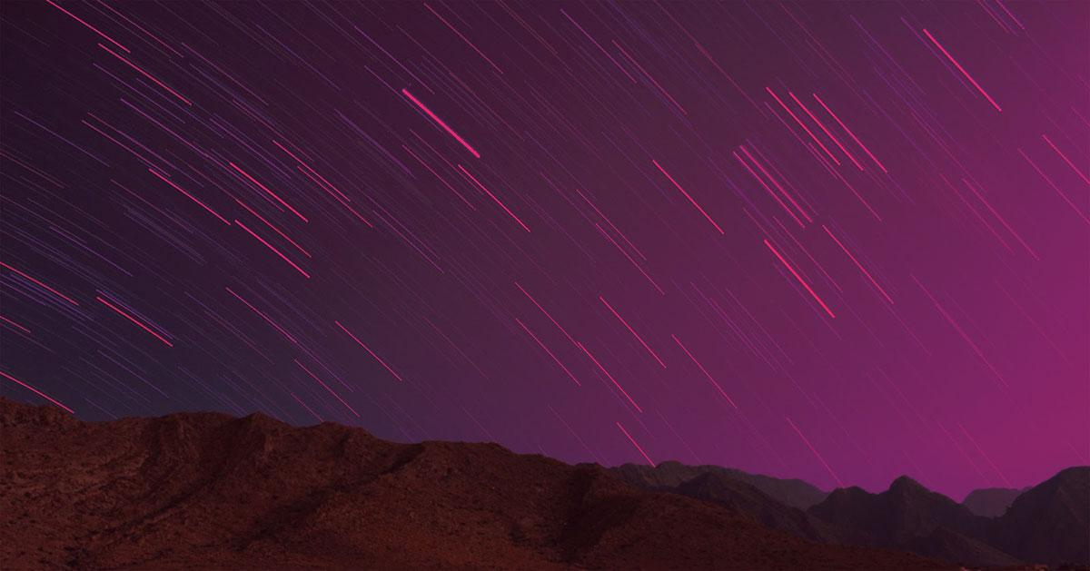
Lorem ipsum dolor sit amet

Background Information for travelers about Plate Tectonics:
Plate tectonics are from the earth’s mantle, specifically called the lithosphere. Tectonic plates are broken pieces of earth’s lithosphere. They are divided into multiple pieces, and they move across each other. There are also plate boundaries. For example, there is the divergent plate boundary, when the plates move away from each other, and the convergent plate boundary, when they collide with each other, and the transform boundary when the plates slide past each other. Tectonic plates move due to the asthenosphere. The asthenosphere is a layer in the earth’s mantle that is thicker and hotter than the lithosphere. In the asthenosphere, there are convection currents that produces the magma that rises up from the mid-atlantic Ridge. The heat rises, causing the plates to separate, then sinks as the temperature drops, causing the plates to collide. Overall, the convection currents are the main force that drives the plate tectonics moving.

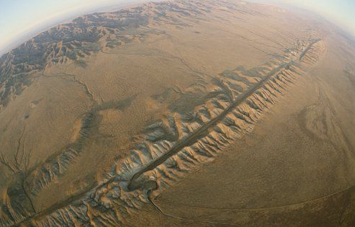
1: The San Andreas Fault
The San Andreas Fault is an active transform boundary. This means that the two plates move, and slide past one another. The Pacific Plate moves northwards with respect to the North American Plate. In this site, there is a fault displacement called the right-lateral strike-slip, which means that if you stand on one side of the fault and looked across it, the block on the other side would look like it moved right. That is why geologists refer this to a right-lateral strike-slip fault. Due to this tectonic activity, it created a valley, which includes fault-related features with it such as scarps, offset streams, ponds, etc. Geologists find this site interesting because they have found several types of rock that did not belong to the San Andreas Fault. They were from the Cargo-Muchacho Mountains near the Mexican border. The Mountains, however, are about 13 miles apart from each other. Travelers should visit this site because they can find many different types of rocks from different places such as Mexico!

Destination 2: The East Pacific Rise
The East Pacific Rise is a mid-ocean ridge that runs from the Gulf of California to the South of Easter Island in the Pacific Ocean. This location has a divergent plate boundary, meaning that it moves away from each other. In this location, there is seafloor-spreading, separating the Pacific Plate from the Cocos Plate. Seafloor-spreading is where new oceanic crust is being generated due to the upwelling in mid-ocean ridges. Beneath the water, there is a mountain range made up of active volcanoes that are constantly erupting with magma. This is one of the causes that contribute to seafloor-spreading. Geologists are interested in this site because the tectonic plates, the Pacific, and the Cocos, are moving apart at one of the fastest rates at anywhere on Earth. It moves about 4.5 inches yearly. Travellers should travel here because you can see the magma erupting from the seafloor.

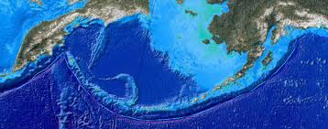
Destination 3: Aleutian Trench
The Aleutian Trench is a trench that runs from the Gulf of Alaska to Kamchatka in Russia. This location is has a convergent plate boundary, meaning that the plates collide with each other, but the denser plate subducts under the less dense plate. This location is a subduction zone, where the Pacific plate subducts under the North American plate, forming the Aleutian Trench. The Pacific plate subducts under the North American plate because it’s denser than the North American plate. The site also contains volcanoes that form an arc, also known as a volcanic arc. The magma from these volcanoes erupt, allowing magma to flow to the surface. This site also contains mountains, from the plates colliding into each other. Geologists find this site interesting because the amount of magma erupting is more than enough to cover the State of California, with a layer that’s one mile thick. Travellers should visit this site so that they can see the mountains that were contain many folds due to the plate colliding.

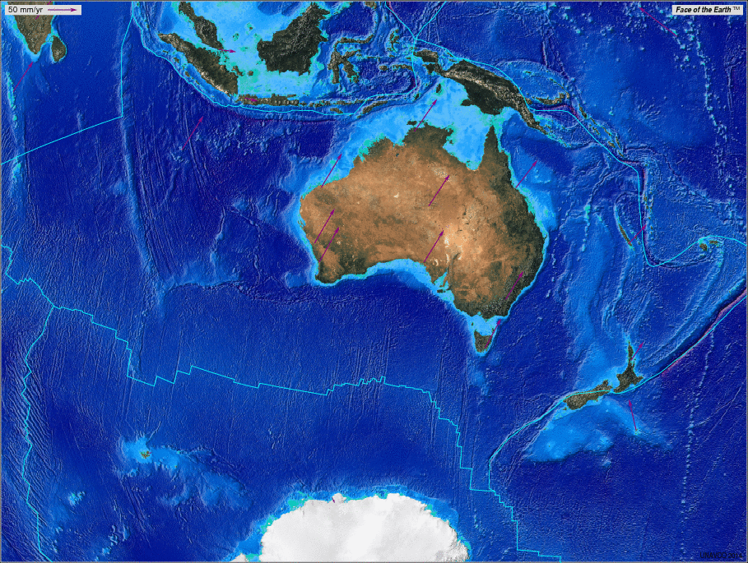
Destination 4: Indo-Australian Plate
The Indo-Australian plate is a major tectonic plate that extends from Australia to the sub-continent, India. This location has a convergent plate boundary, where the Pacific plate is sliding beneath the Indo-Australian plate. This site has volcanic islands due to the northern movement of the Australian plate beneath the Eurasian plate. Also, as a result, there are large Sumatra earthquakes that occur. Geologists are interested in this site because India and Australia only separated 43 million years ago, while it seems like it’s ready to break apart again. The plates are moving at rates such as 3.7 cm and 5.6 cm. This also causes large earthquakes at the bottom of the seafloor. Travellers should visit this site because you can see the plates splitting apart overtime.

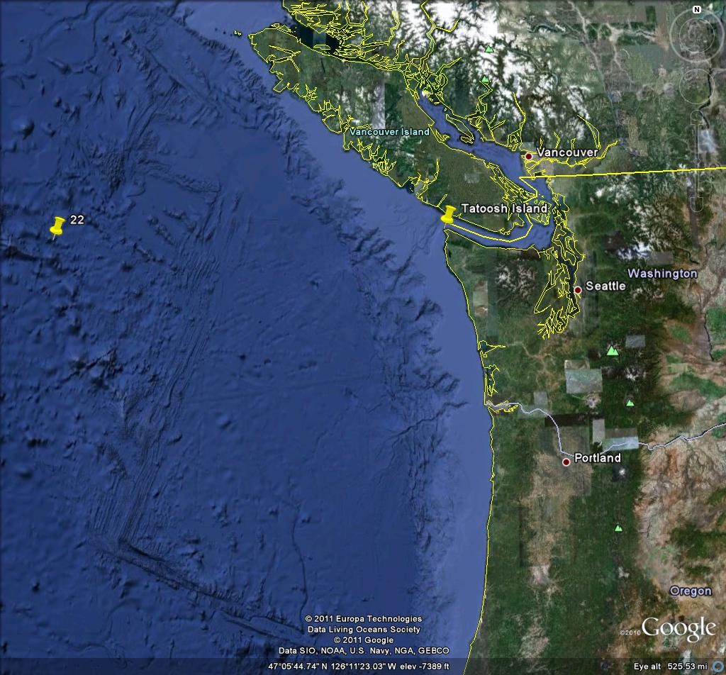
Destination 5: Juan de Fuca Plate
The Juan de Fuca plate is one of the smaller plates we know of today, that is still active. This location has all three plate boundaries, but is mainly known for the convergent plate boundary, where the Juan de Fuca plate subducts below the North American Plate. This site has subduction, which is with the Juan de Fuca plate, and the North American plate. The Juan de Fuca plate subducts below the American plate because it is denser and the North American plate is less dense compared to it. Geologists find this location interesting because when the Juan de Fuca subducts under the North American plate, there is no deep trench like this usually is for subduction zones. The site includes ridges such as the Juan de Fuca ridge and the Gorda ridge. Geologists find this site interesting because it doesn’t have a deep trench even though it is in a subduction zone. Geologists think that this might have to do with the speed of the when the two plates subduct. Travellers should visit this site so that they can witness this plate with all three plate boundaries, and see how mysterious this location is.

